

Email Import Viewer - Lite

|  |  |
| --- | --- |
| Current Document | |
| Date | 15th May 2014 |
| Author | Jeffrey Menashe |
| Document Version | v 0.1 |

**DOCUMENT HISTORY**

|  |  |  |  |
| --- | --- | --- | --- |
| Doc Ver | Date | Author | Change |
| v0.1 | 15th May 2014 | **Jeffrey Menashe** | **Initial Document** |

Table of Contents

1 Scope 1

2 Modifications 2

2.1 PC Authorisation 2

2.2 Mailbox Configuration 2

2.3 Email Import Viewer 3

2.3.1 Selecting Versions 3

2.3.2 Unauthorised PC 3

2.3.3 No Lite Viewer Enabled Mailboxes 3

2.3.4 Search by EmailID 4

2.4 Save Email and/or Attachments 5

2.5 Print Email and/or Attachments 5

# Scope

We need to modify the Email Import Viewer program so it can be run in “Lite” mode on certain machines in production (we can add an entry to the settings table for the Lite Authorised Pcs similar to the Authorised PCs for the CPs). All it would need to do is allow ops to search for an EmailID and save/print the associated attachments. We would only want them to be able to search particular mailboxes (we could add a field to the Mailboxes table which, when ticked, allows it to be searchable in the Email Import Viewer Lite mode).

# Modifications

## PC Authorisation

It is required that PCs are authorised to use the Email Import Viewer Lite Version. In order to enable this, a new entry has been added to the Settings table as follows:-

|  |  |  |
| --- | --- | --- |
| LiteViewerAuthorisedPCs | H07201,H07203,H07204 | NULL |

Any Authorised PC is included in the list of comma separated values.

## Mailbox Configuration

The Mailbox Configuration Program has been modified to allow the marking of a particular mailbox as Lite Viewer Enabled, in other words an Operator using the Lite Viewer Program is able to view emails for this Mailbox. A check box has been added to the General section (highlighted in yellow) which allows this.

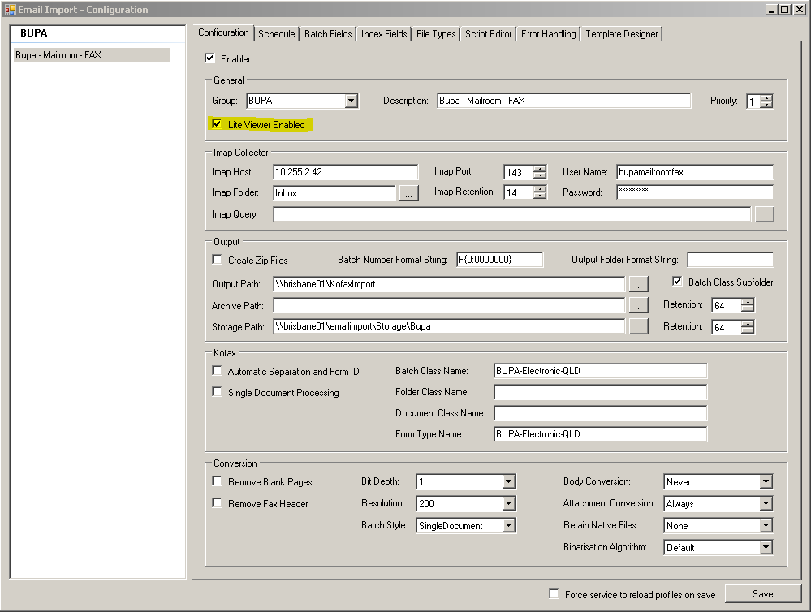

This selection will be saved within the Mailboxes table in the ProfileObject field as below:-

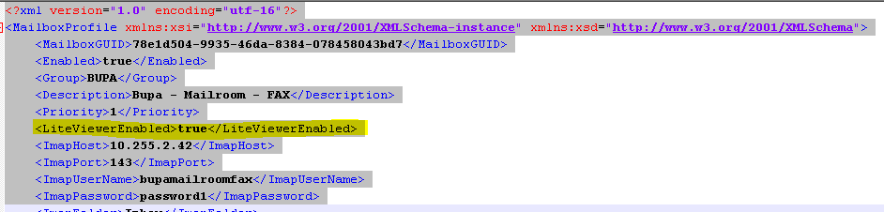

## Email Import Viewer

### Selecting Versions

An argument has been added to the Email Import Viewer program to allow the Operator to specify whether the Viewer must be run in Full Version mode or Lite Version Mode. To run in Full Version Mode the operator runs the following, or creates a shortcut to represent the following:-

EmailImport.Viewer.exe –f, or

EmailImport.Viewer.exe –full

If the above parameters are not added, Lite Mode will automatically be selected.

### Unauthorised PC

If Lite Mode is selected (no parameters appended) and the PC being used is not listed in the LiteViewerAuthorisedPCs value in the Settings table, the Operator will be presented with the following screen and will not be allowed to continue or perform any actions:-

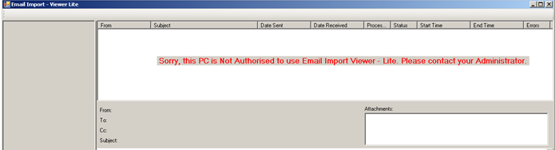

### No Lite Viewer Enabled Mailboxes

If Lite Mode is selected (no parameters appended) and the PC being used is listed in the LiteViewerAuthorisedPCs value in the Settings table, but there not Mailboxes in the current Server that are LiteViewer enabled, the Operator will be presented with the following screen and will not be allowed to continue or perform any actions:-

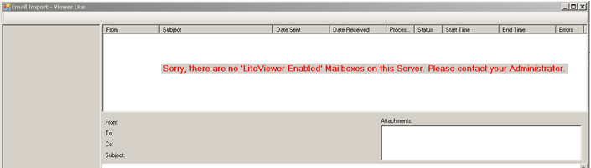

### Search by EmailID

If Lite Mode is selected (no parameters appended) and the PC being used is listed in the LiteViewerAuthorisedPCs value in the Settings table, and there are Mailboxes in the current Server that are LiteViewer enabled, the Operator will be presented with the following screen, with the LiteViewer enabled Mailboxes listed down the left hand side (disabled for viewing purposes only) and a “Find Email using Email ID” button:-

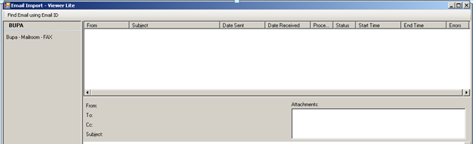

On pressing the Find Email using Email ID button, the operator is presented with the following box, in which to enter the EmailID required:-

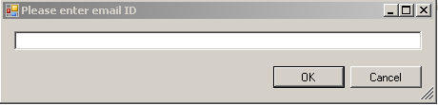

On entering the EmailID and either pressing Enter or selecting the OK button, the system will search for the EmailID among the LiteViewer enabled Mailboxes. If the email is not found within one of the LiteViewer enabled Mailboxes, the operator will be presented with the following screen informing them that matching emails were found:-

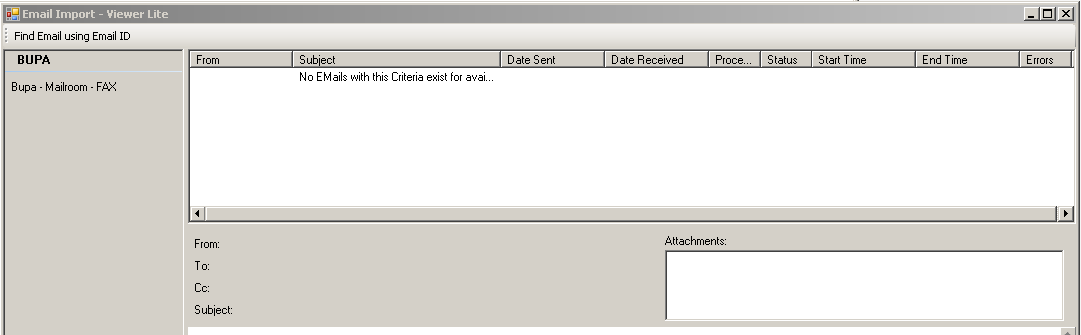

If the email is found within one of the LiteViewer enabled Mailboxes, it will be displayed as follows:-

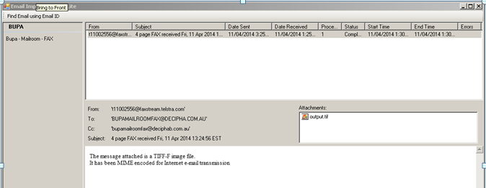

## Save Email and/or Attachments

Once an Email has been successfully located, it and all or some of its’ attachments can be saved. This is performed by right clicking on the listed e-mail and attachments and selecting ‘Save’ from the options presented. The Emails and attachments are then saved in the same manner that any file is saved within the Windows operating system.

## Print Email and/or Attachments

Once an Email has been successfully located, it and all or some of its’ attachments can be printed. The Email is printed by right clicking on the Email contents window below the “Subject” and then selecting Print from the options presented:-

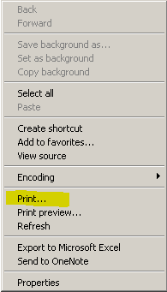

Similarly for attachments, they are printed by double clicking on the attachment which opens it in its respective viewer eg: PhotoViewer, Excel, Word etc … and can then be printed from that viewer as one would normally print a document in that viewer.